# AgentSeal 1.0 – how to run the model

1. The model is coded in NetLogo 6.0.4 available to download for free at <https://ccl.northwestern.edu/netlogo/>. The model should also work on the newer version of NetLogo and should be working both on Mac and Windows OS. See NetLogo User manual for tutorials how to use the software <file:///C:/Program%20Files/NetLogo%206.0.4/app/docs/index.html>.
2. Download all the files from the GitHub AgentSeal repository:
   1. AgentSeal1.0.nlego is the netlogo file containing GUI and the code so once you download NetLogo, double-clock this file and it should load in NetLogo
   2. Put .nlogo file, together with ‘Input’ folder containing all input files necessary to the run the model into one folder. Create also an empty folder called Output as below

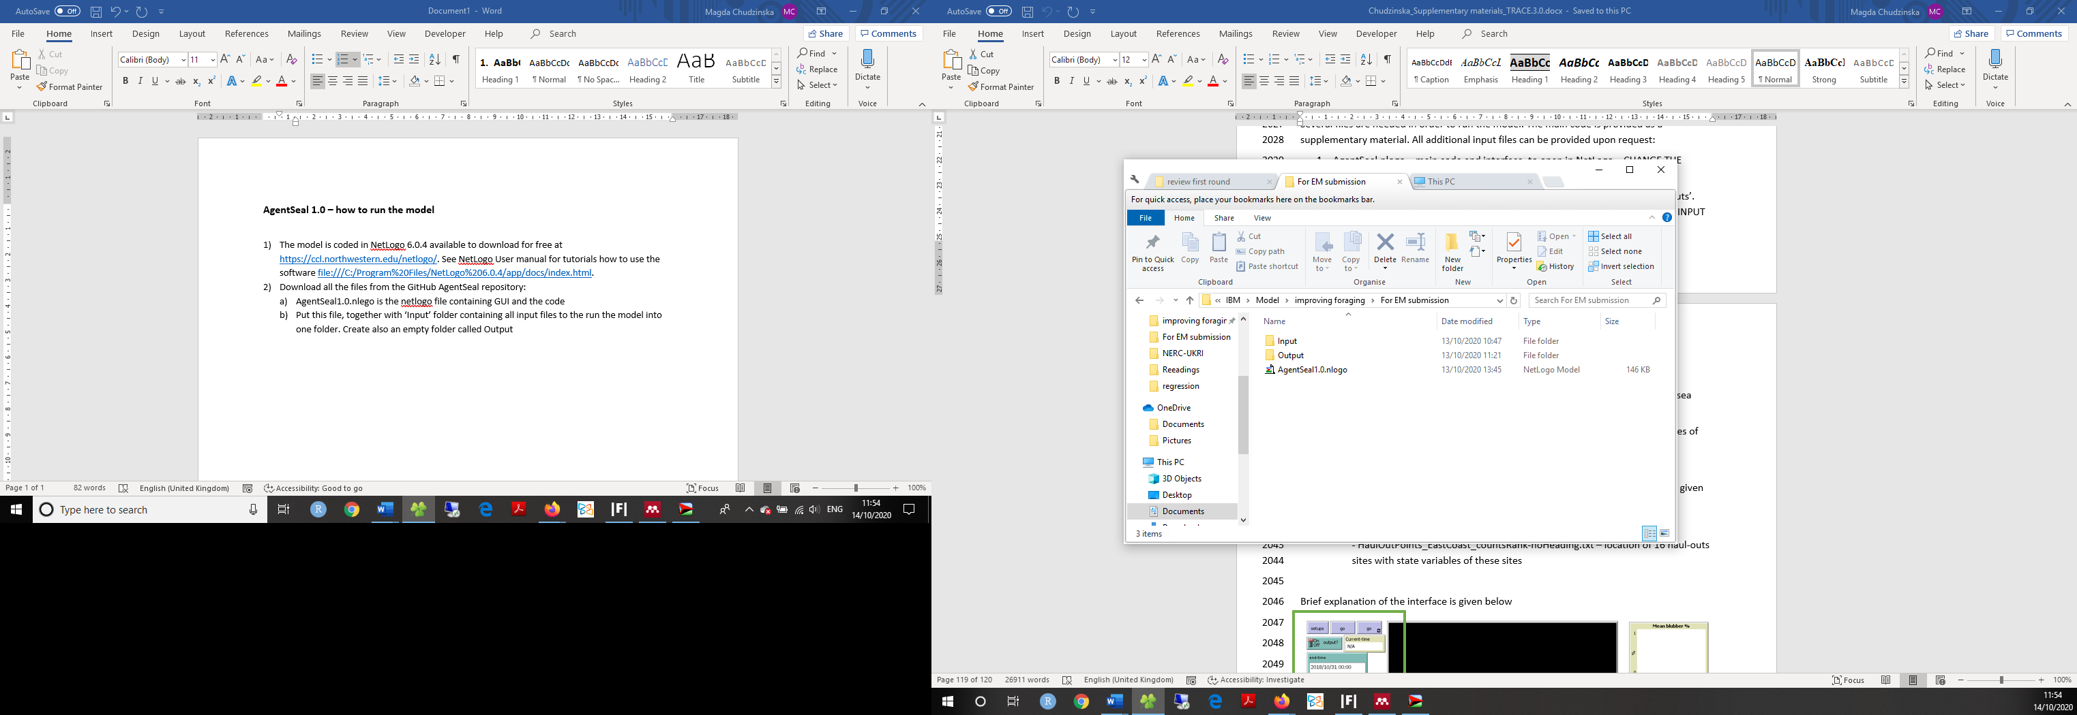

1. If the model ‘complaints’ that it cannot find ‘time’ extension, put the ‘time’ folder in NetLogo depository in ‘extensions’ folder. The newest version of Netlogo should have time extension already included.
2. Input folder contains files necessary in two Procedures: ‘set_landscape’ and ‘load_haulouts’.
   1. ‘set_landscape’:

- GrecianEtAl2018.asc – raster with HSI values of each at-sea patch

- land_distance_EastCoast_noBay.asc – raster file showing distance from each at-sea patch to the coast

- land_EastCoast_5km.asc and land_EastCoast_25km.asc and – 5x5 km and 25x25 km grid ids. Necessary for memory procedures

- ho_distance_id_X.asc – 16 files each showing distance of each patch to a given haul-out site X

- Maxhsi_EastCoast_25km_NoBay.asc – maximum initial value of HSI for each 25x25km grid

* 1. ‘load_haulouts’

- HaulOutPoints_EastCoast.txt – location of 16 haul-outs sites with state variables of these sites

1. Brief explanation of the interface

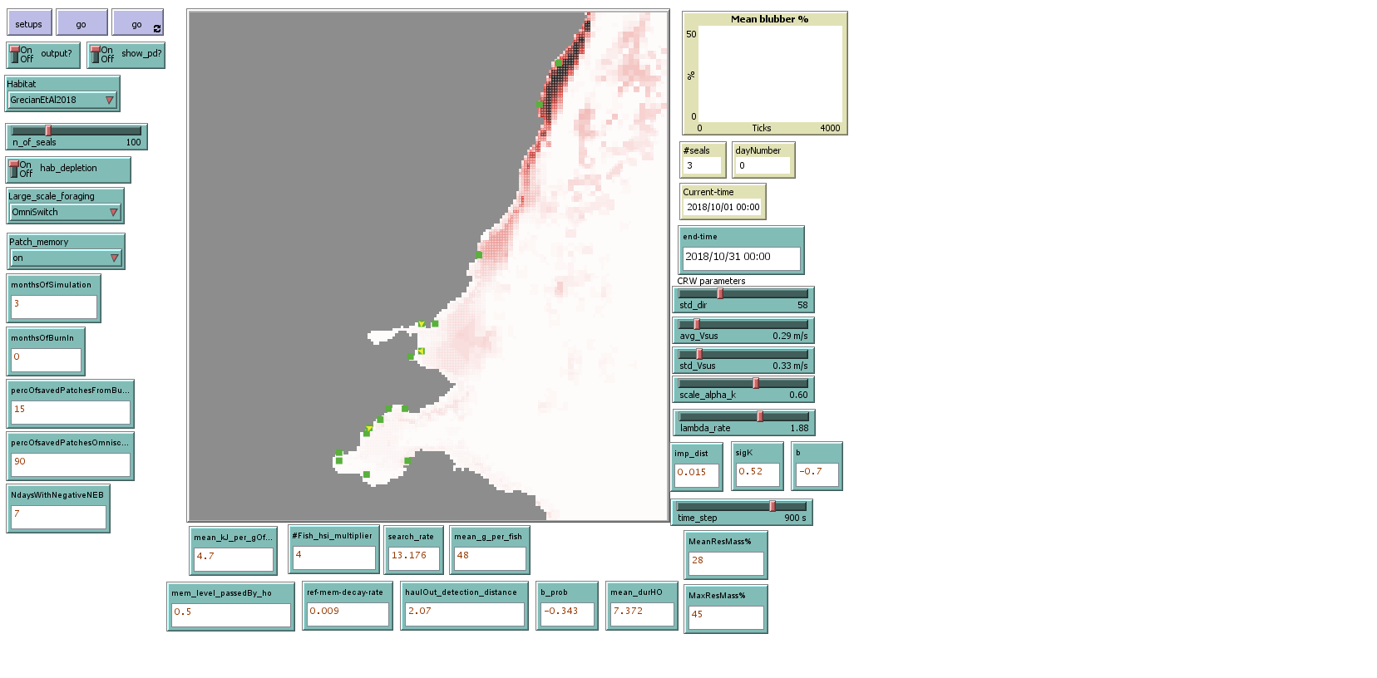

Setup and starting buttons;

switchers defining whether to produce output files, display tracking line (show_pd?) of the *m*seals, and keep food depletion in the model. You can also set here number of seals you want to model. Remember that current version of the model is parameterised for 300 animals

Habitat is set to the default habitat used in the model (GreciamEtAl2018 but user defined habitats are also possible. Large_scale_foraging should be set to ‘OmniSwitch’. Other options available there are subject of another project. Set length of simulation by setting monthsOfSimulations, decimal numbers are allowed, the defualt value is 3 months

Parameters and state variables defining fine-scale movement and biased correlated random walk

See Tables 2 and 7 of TRACE for values used in the model (default values as set below)

Parameters and state variables established during parameter selection see Table 2 in TRACE for description and further references to values used



1. To run the model, press ‘Setup’ and then for one step, or for continuous run until the end of the desired model duration (monthsOfSimulation)